NORMALIZATION AND DATABASE DESIGN

C170 Performance Assessment

Duvall Roberts

**Part A:**

**Nora’s Bagel Bin Database Blueprints**

**First Normal Form (1NF)**

|  |  |
| --- | --- |
| **BAGEL ORDER** | |
| PK | Bagel Order ID |
| PK | Bagel ID |
|  | Order Date |
|  | First Name |
|  | Last Name |
|  | Address 1 |
|  | Address 2 |
|  | City |
|  | State |
|  | Zip |
|  | Mobile Phone |
|  | Delivery Fee |
|  | Bagel Name |
|  | Bagel Description |
|  | Bagel Price |
|  | Bagel Quantity |
|  | Special Notes |

The 1st Normal Form has data redundancy as each data functionally depends on multiple entities.

**Second Normal Form (2NF)**

|  |  |  |  |  |  |  |  |
| --- | --- | --- | --- | --- | --- | --- | --- |
| **BAGEL ORDER** | |  | **BAGEL ORDER LINE ITEM** | |  | **BAGEL** | |
| PK | Bagel Order ID |  | PK / FK | Bagel Order ID |  | PK | Bagel ID |
|  | Order Date | 1:M | PK / FK | Bagel ID | M:1 |  | Bagel Name |
|  | First Name |  |  | Bagel Quantity |  |  | Bagel Description |
|  | Last Name |  |  |  |  |  | Bagel Price |
|  | Address 1 |  |  |  |  |  |  |
|  | Address 2 |  |  |  |  |  |  |
|  | City |  |  |  |  |  |  |
|  | State |  |  |  |  |  |  |
|  | Zip |  |  |  |  |  |  |
|  | Mobile Phone |  |  |  |  |  |  |
|  | Delivery Fee |  |  |  |  |  |  |
|  | Special Notes |  |  |  |  |  |  |

The original Bagel Order column has been split into 3 columns: Bagel Order, Bagel Order Line Item, and Bagel. The Bagel Order table was made because all attributes depend on the primary key, Bagel Order ID, and because they relate to the table. The Bagel table’s attribute is dependent on the primary key, Bagel ID. The attribute in Bagel Order Line Item, Bagel Quantity, is dependent on Bagel Order ID and Bagel ID. The relationship between Bagel Order and Bagel Order Line Item is 1 to M because many Bagel Order line Items can come from just one Bagel Order. The relationship between Bagel Order Line Item and Bagel is M to 1 because many Bagel Order Line Items can belong to just one Bagel.

**Third Normal Form (3NF)**

|  |  |  |  |  |  |  |  |  |
| --- | --- | --- | --- | --- | --- | --- | --- | --- |
| **BAGEL ORDER** | | |  | **BAGEL ORDER LINE ITEM** | |  | **BAGEL** | |
| PK | Bagel Order ID | |  | PK / FK | Bagel Order ID |  | PK | Bagel ID |
| FK | Customer ID | | 1:M | PK / FK | Bagel ID | M:1 |  | Bagel Name |
|  | Order Date | |  |  | Bagel Quantity |  |  | Bagel Description |
|  | Delivery Fee | |  |  |  |  |  | Bagel Price |
|  | Special Notes | |  |  |  |  |  |  |
|  | M:1 |  |  |  |  |  |  |  |
| **CUSTOMER** | | |  |  |  |  |  |  |
| PK | Customer ID | |  |  |  |  |  |  |
|  | First Name | |  |  |  |  |  |  |
|  | Last Name | |  |  |  |  |  |  |
|  | Address 1 | |  |  |  |  |  |  |
|  | Address 2 | |  |  |  |  |  |  |
|  | City | |  |  |  |  |  |  |
|  | State | |  |  |  |  |  |  |
|  | Zip | |  |  |  |  |  |  |
|  | Mobile Phone | |  |  |  |  |  |  |

The attributes reassigned to customer table because the are dependent on Customer ID. Previous relationships are the same. The new relationship is M to 1 because a customer can have many Bagel Orders.

**Final Physical Database Model**

|  |  |  |  |  |  |  |  |  |  |  |
| --- | --- | --- | --- | --- | --- | --- | --- | --- | --- | --- |
| **BAGEL ORDER** | | |  | **BAGEL ORDER LINE ITEM** | | |  | **BAGEL** | |  |
| PK | bagel_order_id | INT |  | PK / FK | bagel_order_id | INT |  | PK | bagel_id | CHAR(2) |
| FK | customer_id | INT |  | PK / FK | bagel_id | CHAR(2) |  |  | bagel_name | VARCHAR(30) |
|  | order_date | TIMESTAMP |  |  | bagel_quantity | INT |  |  | bagel_description | VARCHAR(100) |
|  | delivery_fee | NUMERIC(4,2) |  |  |  |  |  |  | bagel_price | NUMERIC(4,2) |
|  | notes | VARCHAR(150) |  |  |  |  |  |  |  |  |
|  |  |  |  |  |  |  |  |  |  |  |
| **CUSTOMER** | | |  |  |  |  |  |  |  |  |
| PK | customer_id | INT |  |  |  |  |  |  |  |  |
|  | firstName | VARCHAR(20) |  |  |  |  |  |  |  |  |
|  | lastName | VARCHAR(30) |  |  |  |  |  |  |  |  |
|  | address1 | VARCHAR(50) |  |  |  |  |  |  |  |  |
|  | address2 | VARCHAR(50) |  |  |  |  |  |  |  |  |
|  | city | VARCHAR(15) |  |  |  |  |  |  |  |  |
|  | state | CHAR(2) |  |  |  |  |  |  |  |  |
|  | zip | CHAR(5) |  |  |  |  |  |  |  |  |
|  | mobilePhone | CHAR(10) |  |  |  |  |  |  |  |  |

Reflects 3rd Normal Form with correct datatypes and correct names to SQL’s requirements.

**Part B:**

**Jaunty Coffee Co. ERD Database**

1. **Develop SQL code to create each table as specified in the attached “Jaunty Coffee Co. ERD”**

**2) Develop SQL code to populate each table in the database design document**

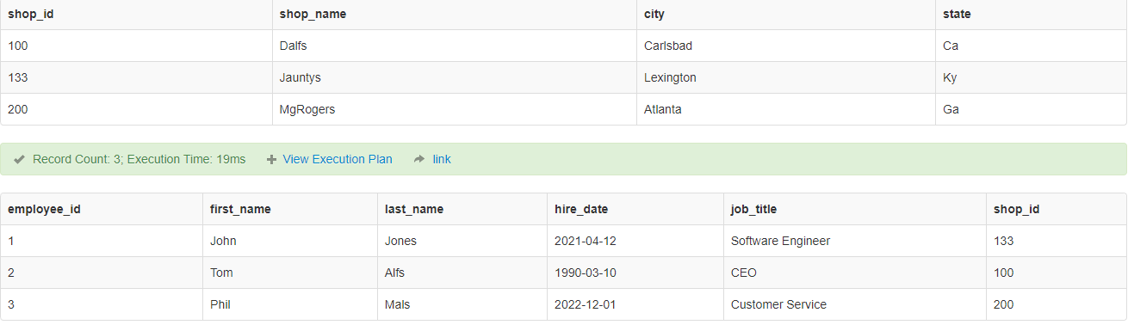

3) Develop SQL code to create a view

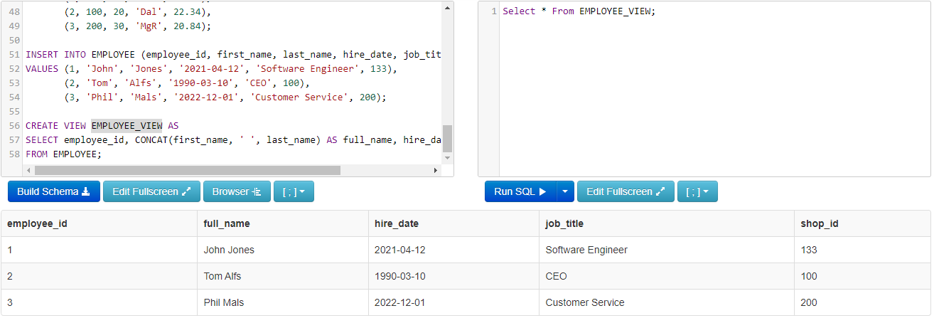

**5) Develop SQL code to create an SFW (SELECT–FROM–WHERE) query for any of your tables or views**

**6) Develop SQL code to create a query**

